HAVE YOUR SAY ON COMMUNITY TRANSPORT
We are seeking contributions to a project that is exploring the ways in which community transport can respond to the changing needs of older people.
Access Sydney Community Transport received a grant from the CHSP Reform Readiness and Innovation Fund to undertake this project in the northern part of the South East Sydney Aged Care Planning Region.
The project is engaging with older people, aged care and community services through surveys and focus groups to inform the development of models of service that respond to older peoples’ changing needs and interests.
Service providers can complete the survey and register for an online forum to be held on 29 April 2026 here: https://www.surveymonkey.com/r/StakeholdersSES
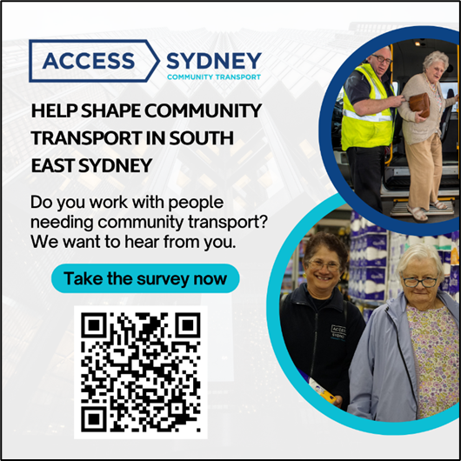
Older people and people with an interest is transport services for older people can complete the survey and register for focus groups here:
Complete the survey online here: https://www.surveymonkey.com/r/transportsescommunity.
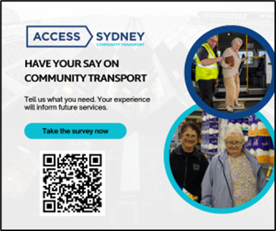
Focus groups will be held in Woolloomooloo on 31 March; Redfern/Waterloo on 8 April; Glebe on 21 April; and Eastlakes/Mascot on 6 May.
More information
For more information contact Tyler Marks or Michael Refshauge on 8241 8000.

