Dementia risk reduction

Stakeholder kit for communicating with people in midlife and primary care practitioners
August 2026

About this toolkit
This kit provides information on reducing dementia risk and includes messaging targeted at primary care practitioners (such as General Practitioners (GPs), nurses, allied health professionals) and people in midlife.
It is aligned to a letter that was distributed in July and August 2026 by the Department of Health, Disability and Ageing to people aged 50 across Australia encouraging them to support their health and reduce their dementia risk.
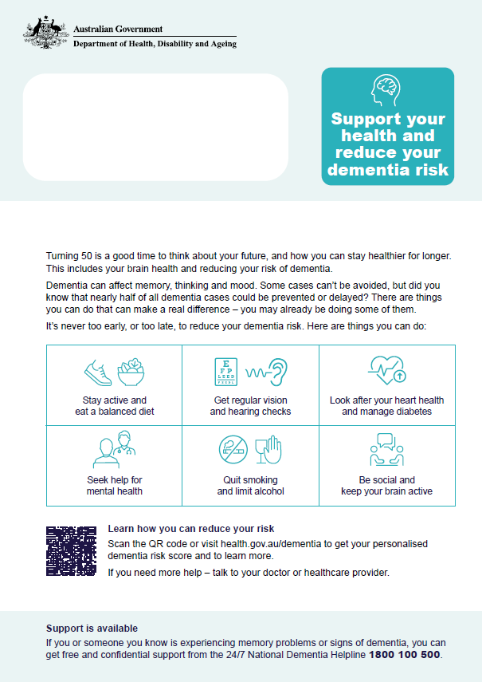
What’s in this toolkit
- key messages
- editorial content
- social media posts

Key messages
For people in midlife
- Midlife is a good time to think about your future, and how you can stay healthier for longer. This includes your brain health and reducing your risk of dementia.
- Dementia can affect memory, thinking and mood. Some cases can’t be avoided, but did you know that nearly half of all dementia cases could be prevented or delayed?
- There are things you can do that can make a real difference – you may already be doing some of them.
- It’s never too early, or too late, to reduce your dementia risk.
- Here are things you can do:
  - Stay active and eat a balanced diet
  - Get regular vision and hearing checks
  - Look after your heart health and manage diabetes
  - Seek help for mental health
  - Quit smoking and limit alcohol
  - Be social and keep your brain active

For primary care audience
- Dementia cases in Australia are projected to increase 2.5-fold by 2065. But, up to 45% of cases could be prevented or delayed by taking action to reduce risk. Reducing and delaying dementia would improve quality of life for many Australians.
- While some cases of dementia cannot be avoided, research shows that addressing 14 modifiable risk factors could prevent or delay nearly half of dementia cases globally.
- The Australian Government reached out to all Australians aged 50 with information on the practical steps they can take to reduce dementia risk and delay onset and progression.
- This information is important for everyone, no matter your age, but we know that improving health in midlife can significantly reduce the risk of developing dementia later in life.
- This activity supports Action 3 of the National Dementia Action Plan (2024–2034), which focuses on improving awareness and reducing dementia risk.

We recommend including a call to action in your communication materials depending on your audience:
For people in midlife
- Learn how you can reduce your risk
Visit health.gov.au/dementia to get your personalised dementia risk score and learn more.
- Support is available
If you or someone you know is experiencing memory problems or signs of dementia, you can get free and confidential support from the 24/7 National Dementia Helpline 1800 100 500.

For primary care practitioners
Access practical tools and resources at health.gov.au/dementia to support preventive care discussions. This includes Aboriginal and Torres Strait Islander and translated resources.

Editorial content
The below content can be included in newsletters or other communication products. There are articles for different audiences.
Editorial for people in midlife
Lower your risk of dementia
Small steps in midlife can help lower your risk of dementia later in life.
While some cases of dementia cannot be avoided, research shows that addressing 14 modifiable risk factors could prevent or delay nearly half of dementia cases.
In July and August, Australians aged 50 received a letter with information on how to reduce dementia risk. But you don’t need to be 50 to make changes. It's never too early or too late to reduce your risk.
You can help protect your brain health by:
- staying active
- eating healthy food
- quitting smoking
- limiting alcohol.
It is also important to:
- manage blood pressure, cholesterol and diabetes
- have regular vision and hearing checks
- stay connected with others
- keep your mind active.
Talk to your GP if you need help.
Learn more about dementia. You can check your dementia risk and find translated and Aboriginal and Torres Strait Islander resources.
Editorial for primary care audience
Supporting dementia risk reduction in primary care
While some cases of dementia cannot be avoided, research shows about 45% of dementia cases could be prevented or delayed by addressing risk factors.
In July and August, the Department of Health, Disability and Ageing sent Australians aged 50 a letter with information about how to reduce dementia risk. You may have patients bring in the letter or a dementia risk assessment report and ask for help.
Improving health in midlife can significantly reduce the risk of developing dementia later in life.
Encourage physical activity, a balanced diet, and managing blood pressure, cholesterol and diabetes. Support smoking cessation, reduced alcohol use, and regular vision and hearing checks, mental wellbeing, social connection, and head injury prevention.
Use routine consultations and health checks, including heart health checks, to identify and address risk early.
Access practical tools and resources at health.gov.au/dementia to support preventive care discussions. This includes Aboriginal and Torres Strait Islander and translated resources.
Social media posts
Below are suggested posts you can publish on your social media channels to raise awareness of the steps that can be taken to reduce dementia risk.

Channel | Copy | Social media tile
LinkedIn | Dementia cases in Australia are projected to more than double by 2065, making prevention and risk reduction more important than ever.  Healthcare providers play an important role by including brain health conversations in their routine preventative care and healthy aging discussions.  While some cases of dementia cannot be avoided, research shows that up to 45% of dementia cases could be prevented or delayed by addressing key risk factors.  Simple steps that can support brain health include:  🔸 staying physically active  🔸 eating a healthy diet  🔸 managing blood pressure, cholesterol and diabetes  🔸 quitting smoking and limiting alcohol  🔸 staying socially connected.  People aged 50 recently received a letter from the Department of Health, Disability and Ageing about taking practical steps now to support brain health and reduce the risk of dementia in later life. But you don’t need to be 50 to make the changes – it's never too early or too late to reduce your risk.  For more information, see the comments below. 👇  First comment:  To learn more, visit 💻 www.health.gov.au/dementia | 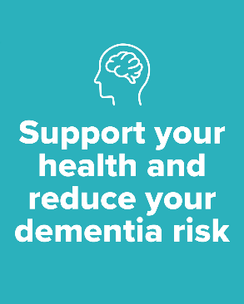
Facebook | Small steps now can lower your risk of dementia later in life. 🧠  Midlife is the perfect time to take action and the good news is, there’s a lot you can do.  While some cases of dementia cannot be avoided, up to 45% of dementia cases could be prevented or delayed by:  💪 staying active  🥗 eating healthy food  👥 staying connected  🩺 managing your heart health and diabetes.  People aged 50 recently received a letter from the Department of Health, Disability and Ageing about taking practical steps now to support brain health and reduce the risk of dementia in later life.  But you don’t need to be 50 to make the changes – it's never too early or too late to reduce your risk.  For more information and to get your personalised dementia risk score, see the comments below. 👇  First comment:  For more information, visit 💻 www.health.gov.au/dementia
X | Small steps now can lower your risk of dementia later. While some cases of dementia cannot be avoided, up to 45% of cases could be prevented or delayed. 🧠  Start the conversation with your GP today or visit 💻 www.health.gov.au/dementia for more information.
Instagram | Small steps now can lower your risk of dementia later. 🧠  Midlife is the perfect time to take action and the good news is, there’s a lot you can do.  While some cases of dementia cannot be avoided, up to 45% of dementia cases could be prevented or delayed by:  💪 staying active  🥗 eating healthy food  👥 staying connected  🩺 managing your heart health and diabetes.  People who recently turned 50 have received a letter about taking practical steps now to support brain health and reduce the risk of dementia in later life.  But you don’t need to be 50 to make the changes – it's never too early or too late to reduce your risk.  Start the conversation with your GP today. For more information and to get your personalised dementia risk score, click 🖱️the link in our bio.  #BrainHealth #DementiaAwareness  Link in bio:  www.health.gov.au/dementia

