Registration Form for Children’s Week 2026
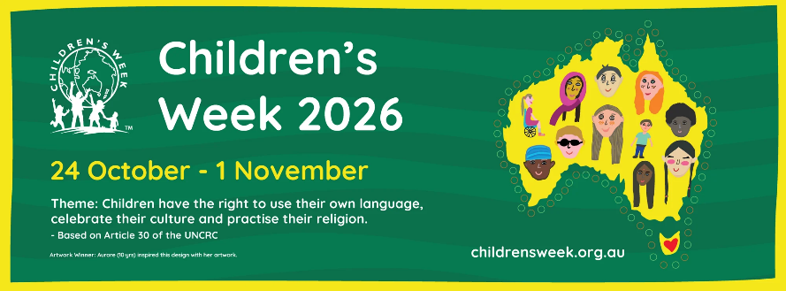
Friday 9 October 2026 | 10.00 am - 12.00 pm | St John's Anglican Church Hall, 431 Princes Highway, Rockdale
The Rockdale Children & Families Hub, in partnership with Better Connected Community Services, Bayside Council and Kogarah Community Services, is hosting a Children’s Week Expo on Friday 9 October 2026, from 10.00 am to 12.00 pm, at St John’s Anglican Church Hall, 431 Princes Highway, Rockdale.
We invite local community services, not-for-profit organisations, NGOs and government services to host an interactive stall for children aged 0-6 years and their families. The celebration provides an opportunity to engage with local families in a fun and welcoming environment, build community connections, and raise awareness of services and supports available in the St George and Bayside areas.

Service/Organisation:

Contact person:

Phone:

Email:

Names of Participating staff:

Description of Stallholder Activity:

Please note:
- Stallholders must arrive and set up between 8.30am – 9.30am to set up
- All stallholders must attend induction and safety procedures 9.45am – 9.50am
- Limit staffing to 2-4 staff per service at any given time due to space constraints
- Avoid painting or any other form of messy play as your chosen children’s activity.
- No balloons or bubbles
**Please complete and return this form to basudha.karki@health.nsw.gov.au along with your certificate of currency form, by 14th September 2026**

